

Bexhill Trust

Annual Report 2023

Constitution

The Bexhill Trust is managed by a body of Trustees comprising up to seven “Ordinary Trustees” appointed by Bexhill Town Council together with the Town Mayor and Deputy Town Mayor as “Ex-Officio Trustees” for their respective terms of office.

Trustees

Chairman – Brian Drayson

Trustees – Sarah Errington, Viv Taylor-Gee, Eleanor Gibson

Ex-Officio (non-voting)

Mayor – Cllr L. Brailsford, Deputy Mayor – Cllr C Winter

Application of Income

The Trust’s funds are at the absolute discretion of the Trustees, applied for the public benefit to recipients within the former Borough of Bexhill* and specifically for:

The relief of poverty

The advancement of education

Any other charitable object of public utility

Meetings

Ad hoc and online meetings were held throughout 2023 to consider Grant applications.

Grants Awarded

Within the year a total of 4 grants were awarded totalling £3850.00

*now within the area administered by Bexhill on Sea Town Council

Finance

Income £ 112.83

Expenditure Grants £ 3,850.00

Unity Service Charge £ 54.00

Clerk Administration £

Total: £ 3,904.00

Surplus: (£3791.17)

Assets

Blackrock Investments (Not including growth) £ 80222.53

NatWest (Suspended account) £ 40,000.00

Unity Savings Account £ 5,904.59

Unity Current Account £ 6,500.35

Total: £132,627.47

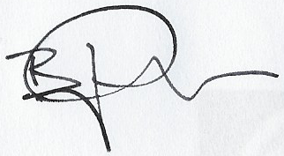

Brian Drayson

Chair

